> head(max(average_acc_history$validation_acc))

[1] 0.9622688

> # Evaluate on Testset

> eval <- evaluate(model, test_data, test_targets, verbose = 1)

423/423 [==============================] - 20s 48ms/step - loss: 1.9444 - categorical_accuracy: 0.7309

> head(eval)

loss categorical_accuracy

1.9443891 0.7309029

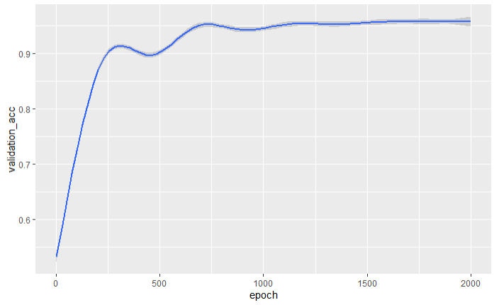

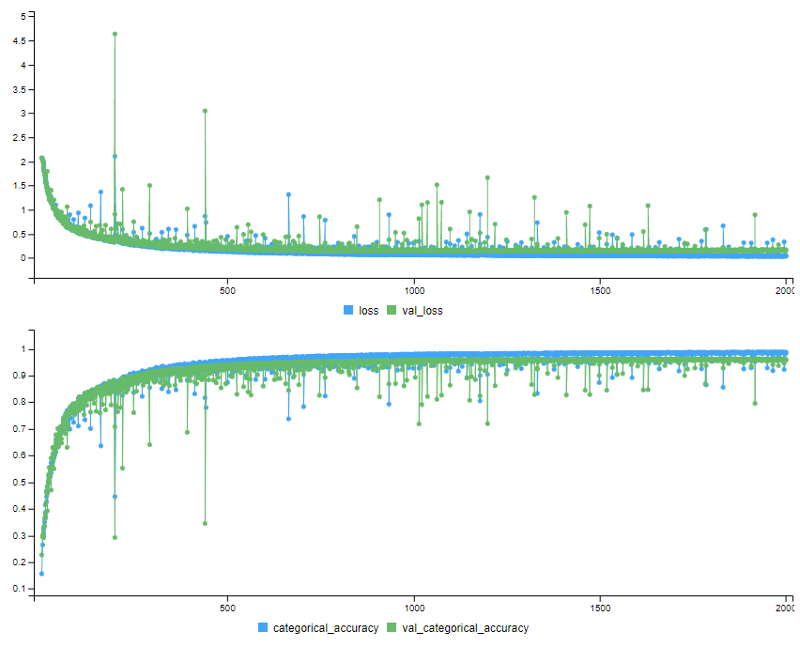

## Build Model

```{r}

#train_data <- matrix_data

train_data <- data.matrix(matrix_data)

test_data <- data.matrix(matrix_data_test)

train_targets <- data.matrix(matrix_targets)

test_targets <- data.matrix(matrix_targets_test)

# Function to build the model

build_model <- function() {

model <- keras_model_sequential() %>%

#layer_batch_normalization(axis = -1L, input_shape = dim(train_data)[[2]]) %>%

layer_dense(units = 128, activation = "relu", input_shape = dim(train_data)[[2]]) %>%

layer_dense(units = 128, activation = "relu") %>%

layer_dense(units = 256, activation = "relu") %>%

layer_dense(units = 256, activation = "relu") %>%

layer_dense(units = 128, activation = "relu") %>%

#layer_dropout(0.3) %>%

layer_dense(units = 8, activation = "softmax")

model %>% compile(

optimizer = optimizer_sgd(learning_rate = 0.1),

#optimizer = optimizer_adam(),

loss = "categorical_crossentropy",

metrics = "categorical_accuracy"

)

}